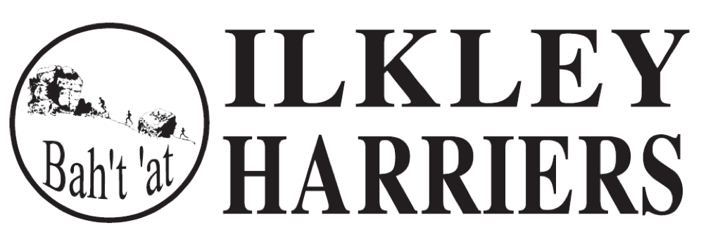

Committee Minutes

25th September 2018 at ILTSC

Present: Neil Chapman, Hilda Coulsey, Geoff Howard, Peter Lewis, Jane McCarthy, Helen Waddington, Sue Williamson.
Apologies: Jean Sullivan/Richard Joel, Martin Archer, Caroline Howe
Minutes of Meeting 21st September: Agreed
Matters arising: all discussed below

Running the Club

- Outstanding Achievements for the Month of August 2018

Nominations for August

Euan Brennan for GB selection for U20 (at 17) and very impressive results
Rachel Carter 1st Round Hill fell race, 3rd lady at Hellifield gala, 1st lady in the Dutch 5k
Jemima Elgood 1st at King's Challenge
Will Simmons 2nd at Round Hill, 4th at Burnsall 10 mile
Helen Waddington for UTMB OCC finishing in top third for her category and impressive commitment to training.

Paul Wood for maintaining the website, including the Forums

2. Events

Incline: Entries were up this year from last and enjoyment was expressed by all, as usual! Thank you to Helen and the many other helpers. Helen is looking to hand organisation over next year. HW
Harriers League: We are considering the fairness of the wildcard, particularly used for park runs. This and the age grading factors will be reviewed prior to the 2019 competition.JMcC
IMFR: The FRA listings and entries are in process and our arrangements re fee and cut-off need to be finalised. MA/ JMcC

3. Northern Athletics

NA have declared that we must affiliate to them by 1st October and pay £2 per EA registered member in order to compete in their events. We have had various conversations with NA, EA and also WYA to help to clarify what the benefits of affiliating with NA are and to understand the role of EA. We have decided that we wish to retain the same mix of members we have now; representative level athletes, those enjoying the opportunity of completion at the range of levels and those who are not interested in competing. Therefore although only some 10% of members will benefit from affiliation, we propose to affiliate but to continue discussion with NA and EA aiming to influence their decisions through this year regarding EA and NA funding so that a fairer arrangement can be agreed. The cost to IH (seniors and juniors) is £704 which we propose to absorb this year because of a surplus maintaining the same membership fees for next year. HC

3. Training sessions
Nothing further discussed however at the AGM recruits for coaching was proposed for promotion again. HC

4. Membership update

Awaiting agreement at AGM and subsequently agreed as proposed to maintain the same fees and structure as 2017/2018 except that student/ youth fee should be the EA £15. PB

6. Junior update

Nothing to discuss this month.

7. Actions from the AGM, after this meeting

- updating and reviewing committee and roles
- NA affiliation, WYA , EA: ongoing dialogue and actions for the next few months
- banking arrangements actions.

Developing the Club

  - Development plan

To be reviewed and updated by year end and tabled for meeting after AGM. HC
2. Junior Facilities

No change to report.

Meeting was followed by the AGM

Next Committee Meeting Tuesday November 6th at 7:30 at ILTSC for discussion on end of year socials and awards and planning for 2019.

